|  |  |
| --- | --- |
| hkust_logo | **The Hong Kong University of Science and Technology**  **Department of Electronic and Computer Engineering** |

Elec2400 **ELECTRONIC CIRCUITS** Fall 2021-22

Lab Section No. : \_\_\_\_\_\_\_\_\_\_\_\_\_\_\_\_\_\_\_\_\_\_\_\_\_\_\_\_\_\_\_ Date : \_\_\_\_\_\_\_\_\_\_\_\_\_\_\_\_\_\_\_\_\_

Name : \_\_\_\_\_\_\_\_\_\_\_\_\_\_\_\_\_\_\_\_\_\_\_\_\_\_\_\_\_\_\_\_\_\_\_\_\_\_\_ Student Number : \_\_\_\_\_\_\_\_\_\_\_\_

**Lab 5b – Audio Equalizer**

**Q1.** Find the center frequency of the high frequency band-pass filter. \_\_\_\_\_\_\_\_\_\_\_\_\_\_\_\_

**Q2.** Find the gain of the high frequency band-pass filter at the center frequency. \_\_\_\_\_\_\_\_\_\_\_\_\_

**Q3**. Find the gain of the high frequency band-pass filter at one decade **below** the center frequency.

\_\_\_\_\_\_\_\_\_\_\_\_\_

**Q4**. Find the gain of the middle frequency band-pass filter at the center frequency. \_\_\_\_\_\_\_\_\_\_\_\_

**Q5**. Find the gain of the middle frequency band-pass filter at one decade **below** the center frequency.

\_\_\_\_\_\_\_\_\_\_\_\_\_\_

**Q6**. Find the gain of the low frequency band-pass filter at the center frequency. \_\_\_\_\_\_\_\_\_\_\_\_\_\_

**Q7**. Find the gain of the low frequency band-pass filter at one decade **above** the center frequency.

\_\_\_\_\_\_\_\_\_\_\_\_\_

**Q8**. Ask the TA to check/test your equalizer. (TA’s name) \_\_\_\_\_\_\_\_\_\_\_

**Q9**. Measure the magnitude of different frequency, and calculate the gain.

|  |  |  |  |  |  |  |
| --- | --- | --- | --- | --- | --- | --- |
| Freq(Hz) | 80 | 100 | 200 | 500 | 800 | 1k |
| Vout (V) |  |  |  |  |  |  |
| Gain (Vout/Vin) |  |  |  |  |  |  |

|  |  |  |  |  |  |  |  |
| --- | --- | --- | --- | --- | --- | --- | --- |
| Freq(Hz) | 2k | 5k | 8k | 10k | 20k | 50k | 80k |
| Vout (V) |  |  |  |  |  |  |  |
| Gain (Vout/Vin) |  |  |  |  |  |  |  |

**Q10**. Plot the frequency response of the equalizer in the semi-log graph.

(x-axis (freq) in logarithmic scale, y-axis (gain)in linear scale.)

You could use drawing tools in Microsoft Word to complete the plot, or you could use

other software to plot the curve, like Excel, and insert the drawing below.)

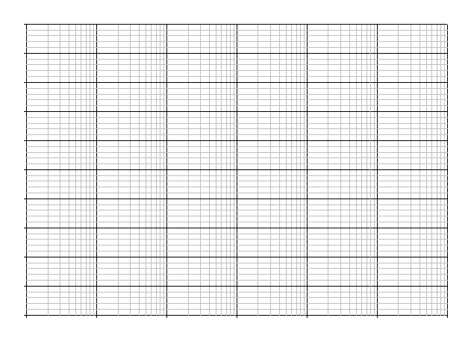

Hz

10

100

1k

10k

100k